

NOTRE DAME UNIVERSITY
BANGLADESH
Assignment - 01

Course Title: Technical Writing & Presentation Lab
Course Code: CSE 3207

Submitted by:
Name: Istiak Alam
ID: 0692230005101005
Batch: CSE-20
Submission Date: 18-04-25
Assignment Topic: Basic of LaTeX

Submitted to:
Md. Tahmid Hasan,
Lecturer, Depertment of CSE,
Notre Dame Univesity Bangladesh

Questions :
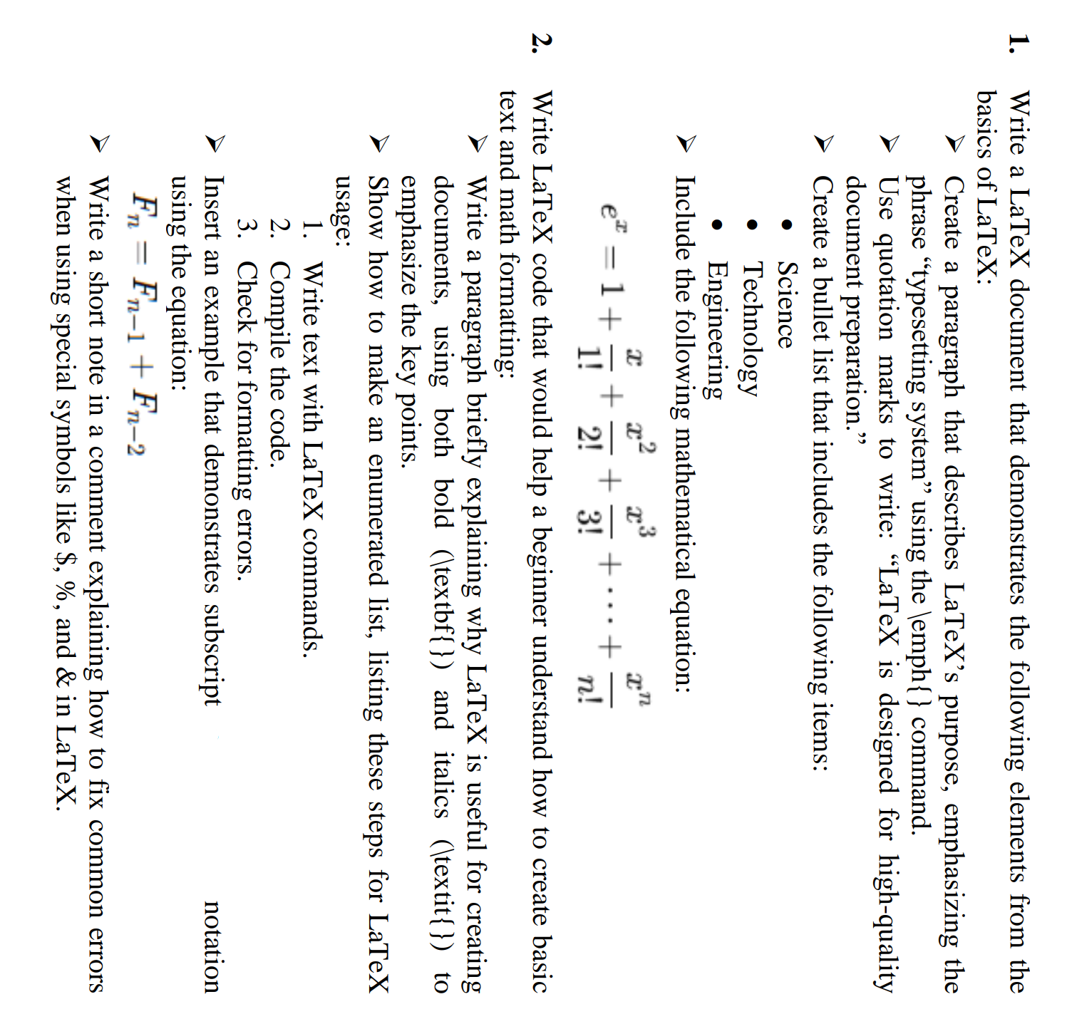

Answers :
Code in Texmaker :
\documentclass[13pt]{article}
\usepackage{amsmath}
\begin{document}
\title{Assignment - 01 : \\ Basic of LaTeX \& Math Formatting}
\author{Istiak Alam}
\maketitle
% Answer to The Question No. 1
\begin{center}
\section*{\underline{Answer to The Question No. 01}}
\end{center}
\subsection*{Basics of LaTeX}
LaTeX is a powerful \emph{typesetting system} designed for the creation of high-quality documents, particularly those containing complex elements like mathematical formulas, scientific symbols, and structured formatting. Its purpose is to provide authors with a consistent and professional layout, making it ideal for academic papers, theses, research articles, and technical documentation. Unlike traditional word processors, LaTeX separates content from formatting, allowing users to focus on writing while ensuring a clean and precise presentation. Its flexibility and precision have made it a standard tool in the scientific and academic communities.\\
In short, LaTeX is a document preparation system and a \emph{typesetting system} widely used for producing scientific and technical documents.\\
\begin{center}
\textbf{``LaTeX is designed for high-quality document preparation.''}
\end{center}
\subsection*{Bullet List Example:}
\begin{itemize}
\item Science
\item Technology
\item Engineering
\end{itemize}
\subsection*{Mathematical Equation:}
\begin{equation*}
e^x = 1 + \frac{x}{1!} + \frac{x^2}{2!} + \frac{x^3}{3!} + \cdots + \frac{x^n}{n!}
\end{equation*}
% Answer to The Question No. 2
\begin{center}
\section*{\underline{Answer to The Question No. 02}}
\end{center}
\subsection*{LaTeX Code for Text and Math Formatting}
\textbf{LaTeX is useful for creating documents} because it provides \textbf{high-quality typesetting}, especially for \textit{technical} and \textit{scientific writing}. It helps maintain \textbf{consistency} and \textit{professional formatting} throughout large documents. Moreover, LaTeX gives users fine control over the structure, citations, equations, and layout, making it an essential tool in academic and research settings.
\subsection*{Enumerated List for LaTeX Usage}
\begin{enumerate}
\item \textbf{Write text with LaTeX commands:\\}
Compose a document using LaTeX syntax for formatting, equations, sections, etc.
\item \textbf{Compile the code:\\}
Use a LaTeX editor or command-line tool (like \texttt{pdflatex}) to compile the `.tex' file into a PDF.
\item \textbf{Check for formatting errors:\\}
Review the output and log messages for any syntax or formatting issues that need to be corrected.
\end{enumerate}
\subsection*{Subscript Notation}
\textbf{Fibonacci Equation :}
\begin{equation*}
F_n = F_{n-1} + F_{n-2}
\end{equation*}
% Note for LaTeX beginners:
% Special characters like $, %, &, #, _, {, and } have special meanings in LaTeX.
% To use them as normal text, you need to escape them using a backslash.
% For example: \$, \%, \&, \_, \{, and \}.
\end{document}

Output PDF of Texmaker :

